BIOINFORMATICS TASK 1 REPORT

Task 1
Title:
DNA/Protein Sequence Analysis using NCBI BLAST
By: Anshara Maheen

- Introduction
In this task, a DNA or protein sequence was examined using the NCBI BLAST tool. BLAST, which stands for Basic Local Alignment Search Tool, is used to compare a query sequence against a database to identify similarities. This helps in detecting homologous sequences and understanding evolutionary relationships. The E-value represents the likelihood that the similarity between sequences occurred by chance. Lower E-values indicate more significant matches and stronger biological relevance.

NCBI
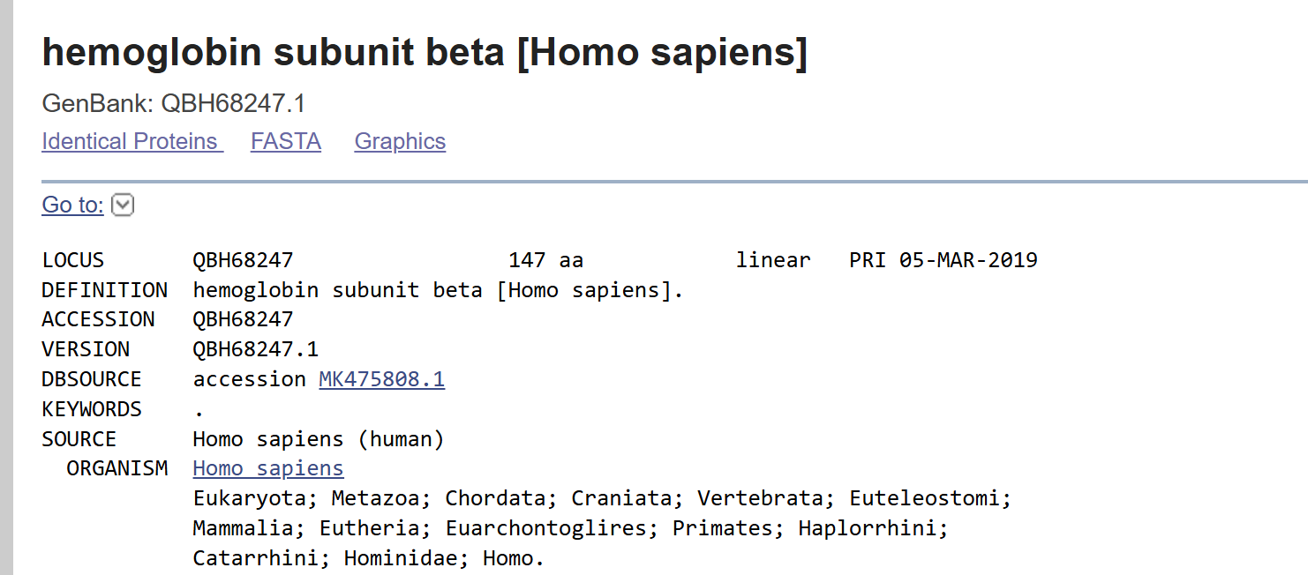
- Sequence Source
The protein sequences were retrieved from the NCBI database in FASTA format and analyzed using BLASTP (Protein BLAST).
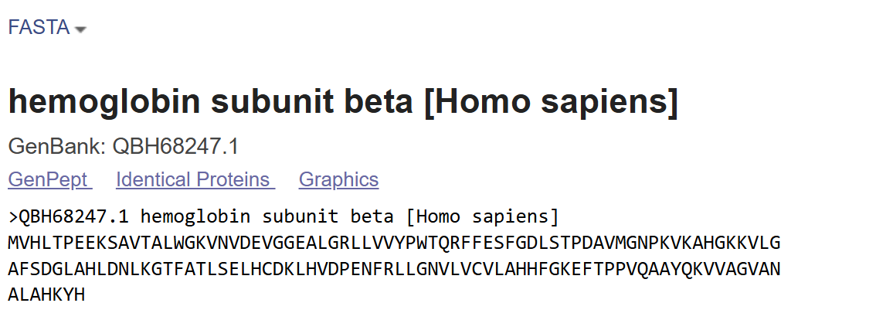

- BLAST Analysis Overview
BLASTP was specifically used for comparing protein sequences to compare a query sequence against database sequences. It provides key metrics such as identity, similarity, alignment score, and E-value to evaluate the significance of matches.
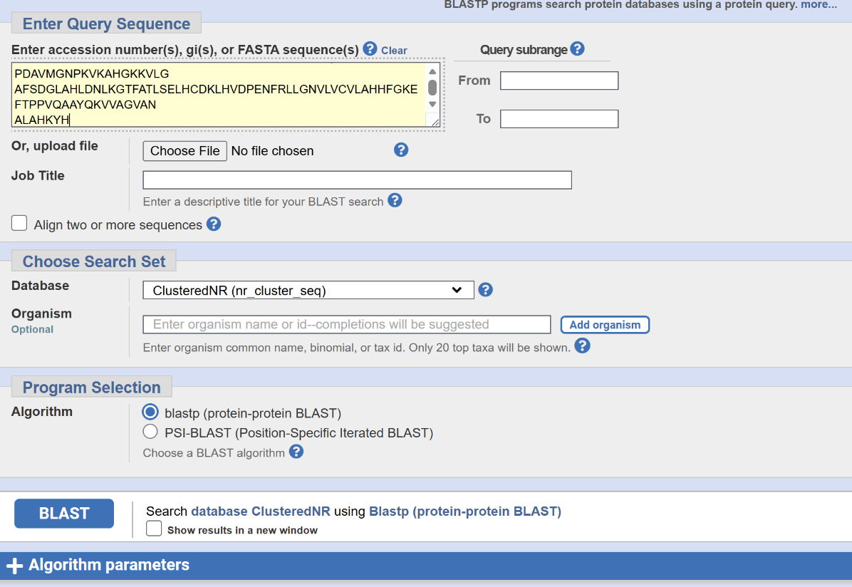
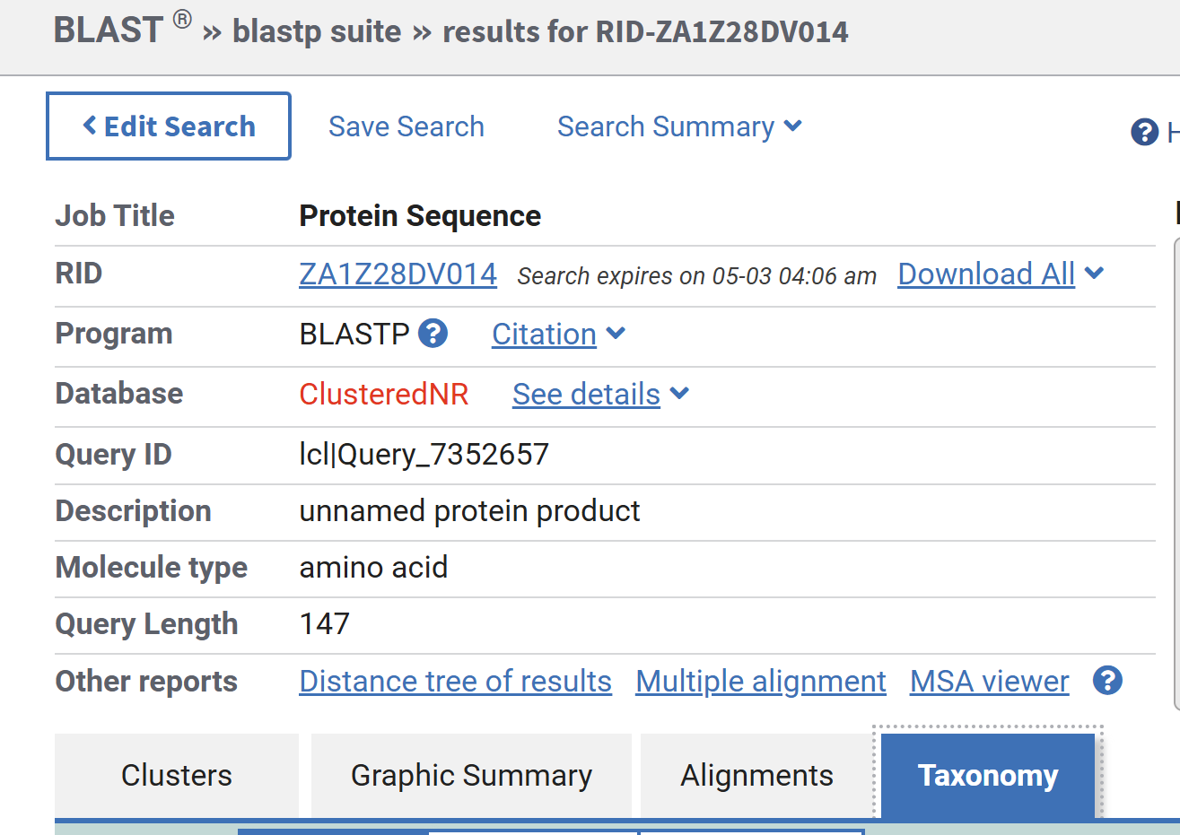

- Graphical Summary
The graphical output illustrates alignment scores and regions of similarity between the query sequence and the matched sequences.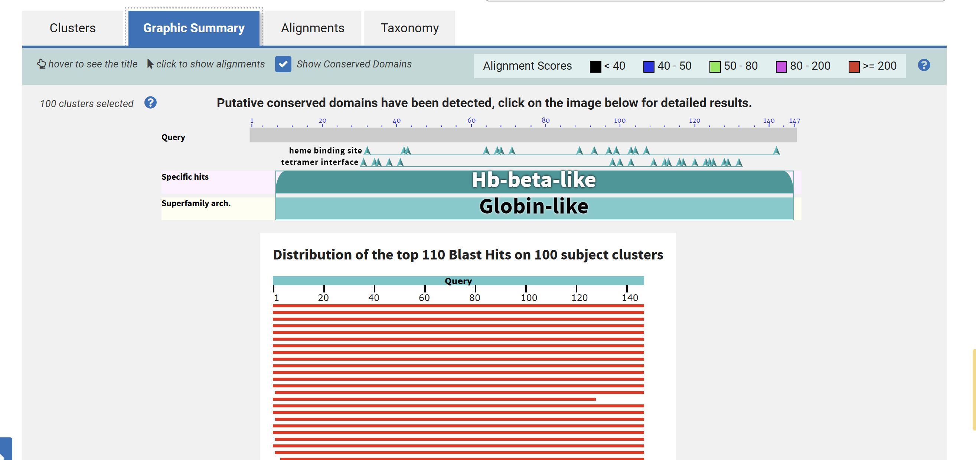
- Sequence Alignments
Pairwise sequence alignments were generated during the BLAST search.
5.1 Hb Monza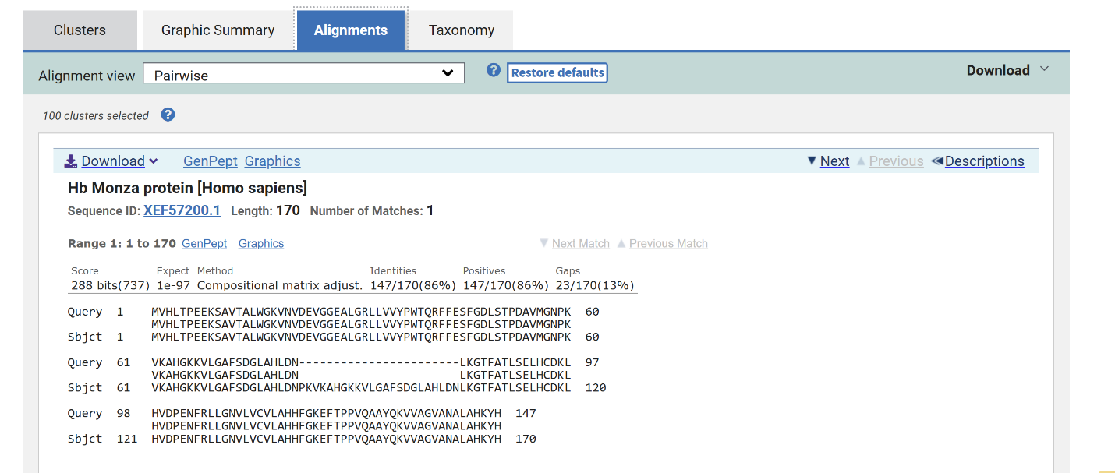

Hb Monza (Homo sapiens)
- Length: 170 amino acids
- Score: 288 bits
- E-value: 1e-97
- Identity: 86% (147/170 amino acids)
- Gaps: 13%
- Similarity: Strong amino acid similarity indicating conserved protein function.
Analysis:
The extremely low E-value indicates a highly significant match, while the high identity percentage reflects strong similarity, suggesting that hemoglobin is evolutionarily conserved in humans.
The high similarity between sequences indicates that amino acids with similar chemical properties are conserved, helping maintain the protein’s structure and function.

5.2 Hypothetical Protein (Panda)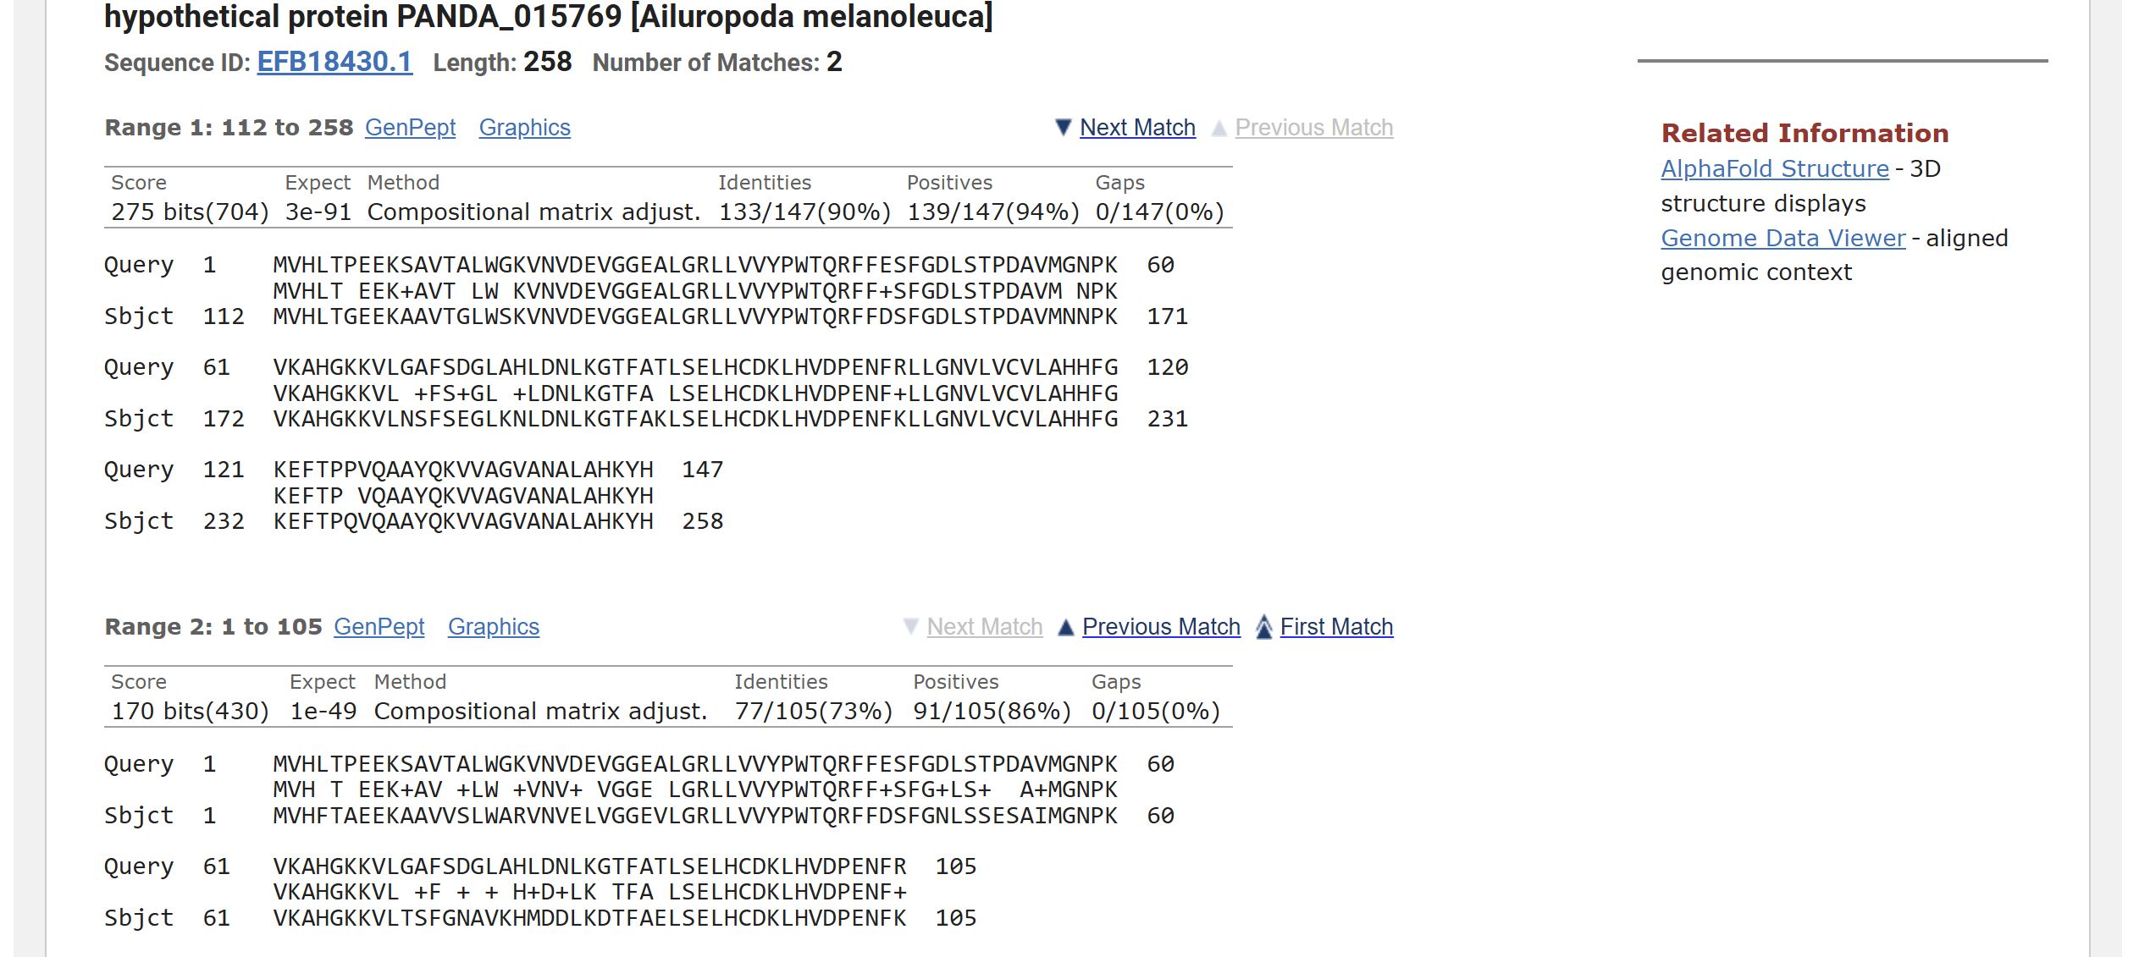

Hemoglobin Subunit Beta-like (Ailuropoda melanoleuca)
- Identity: 90% (133/147 amino acids)
- Score: 275 bits
- E-value: 3e-91
- Second match: 73% identity, E-value 1e-49
- Similarity: High similarity across mammalian globin proteins
Analysis:
The results demonstrate strong homology across different species, and the very low E-values confirm that the similarity is statistically significant.
The observed similarity suggests that functionally important amino acids are preserved across species, contributing to the stability of the protein.
5.3 Beta-Globin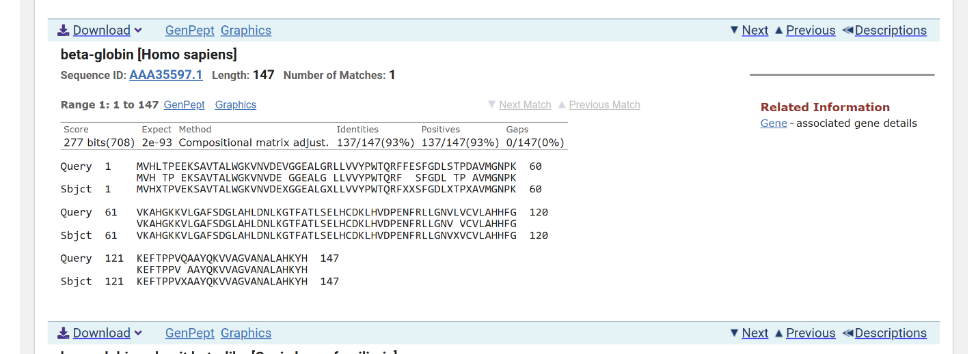

Beta-Globin (Homo sapiens)
- Identity: 93% (137/147 amino acids)
- Score: 277 bits
- E-value: 2e-93
- Gaps: None
Analysis:
This sequence exhibits very high conservation with near-perfect alignment, indicating significant biological importance and evolutionary stability.
The strong similarity highlights the conservation of key amino acid residues required for proper protein function.

- Taxonomy Analysis:
The taxonomy analysis confirms that the protein sequences are highly conserved among related species, supporting their evolutionary significance and functional similarity across different organisms.
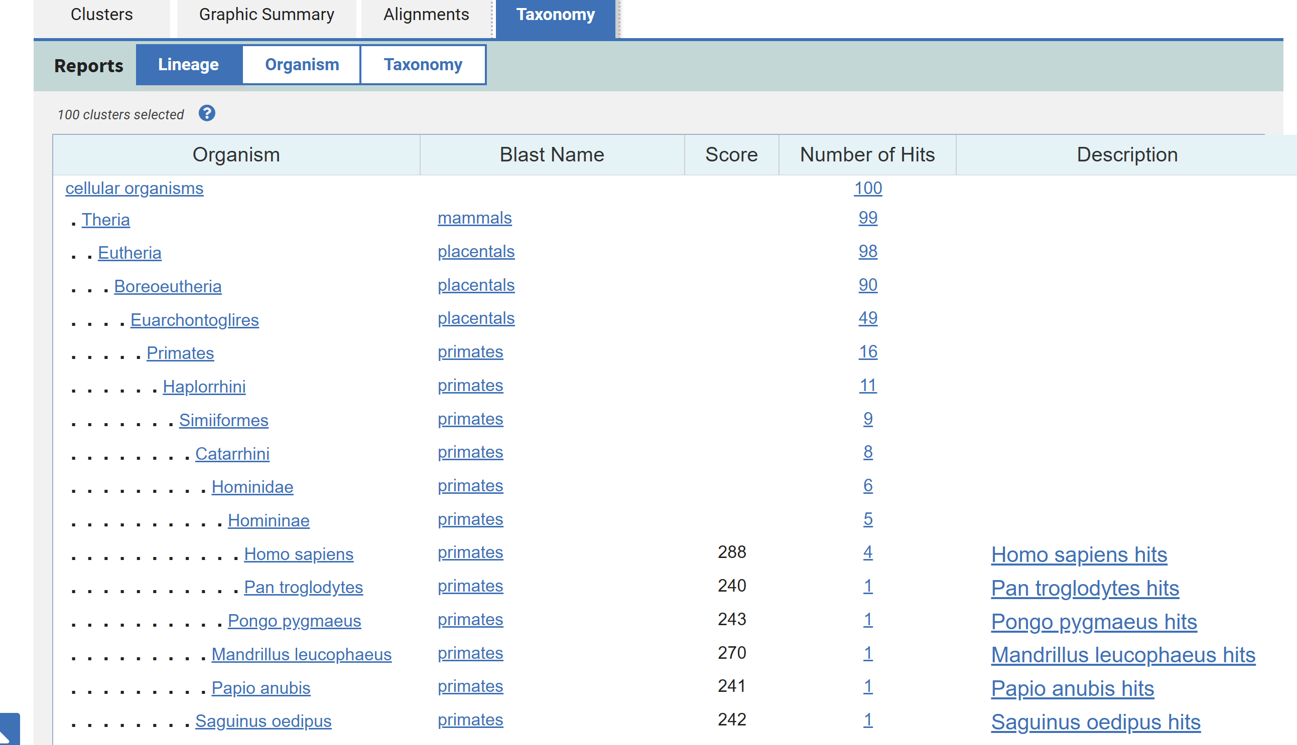

Conclusion
The BLAST analysis effectively identified homologous protein sequences with high similarity scores and very low E-values. The findings confirm the evolutionary conservation of important proteins such as hemoglobin and beta-globin. This highlights BLAST as a reliable tool for sequence comparison and biological research. Overall, the analysis demonstrates that conserved sequences play a crucial role in maintaining protein structure and function across different species.

References
[1] National Center for Biotechnology Information (2025) BLAST: Basic Local Alignment Search Tool. Available at: NCBI BLAST (Accessed: 19 May 2026).
[2] National Center for Biotechnology Information (2025) Protein Database. Available at: NCBI Protein Database (Accessed: 19 May 2026).
[3] Stephen F. Altschul, Warren Gish, Webb Miller, Eugene W. Myers and David J. Lipman (1990) ‘Basic local alignment search tool’, Journal of Molecular Biology, 215(3), pp. 403–410. Available at: Journal of Molecular Biology - BLAST Paper (Accessed: 19 May 2026).

